| **Test Name** | | | Menu Can Open Home Dashboard | | | |
| --- | --- | --- | --- | --- | --- | --- |
| **Use Case Tested:** | | | Return To Home Dashboard | | | |
| **Test Description:** | | | The “Home” menu option is clicked and the home dashboard is shown as a result. | | | |
| **Pre-conditions** | | | Must Not Be On The Home Screen | | | |
| **Post-conditions** | | | The currently displayed window should be that of the home dashboard | | | |
| **Notes:** | | **Unsure how else to demonstrate a button click other than through screenshots.** | | | | |
| **Result (Pass/Fail/Warning/Incomplete)** | | **Pass** | | | | |
|  | **TEST STEP** | | | **EXPECTED TEST RESULTS** | P | F |
|  | Click On Home On Menu | | | Home Dashboard Is Displayed | X |  |
|  |  | | |  |  |  |
|  |  | | |  |  |  |

|  |  |  |  |  |  |
| --- | --- | --- | --- | --- | --- |
| **Test Data Table** | | | | | |
|  | **1** | **2** | **3** | **4** | **5** |
| [Data field 1] | [data set 1 input value for field 1] |  |  |  |  |
| [Data field 2] | [data set 1 input value for field 2] |  |  |  |  |
| [Data field 3] | [data set 1 input value for field 3] |  |  |  |  |

**Test Output Screenshots**

Start

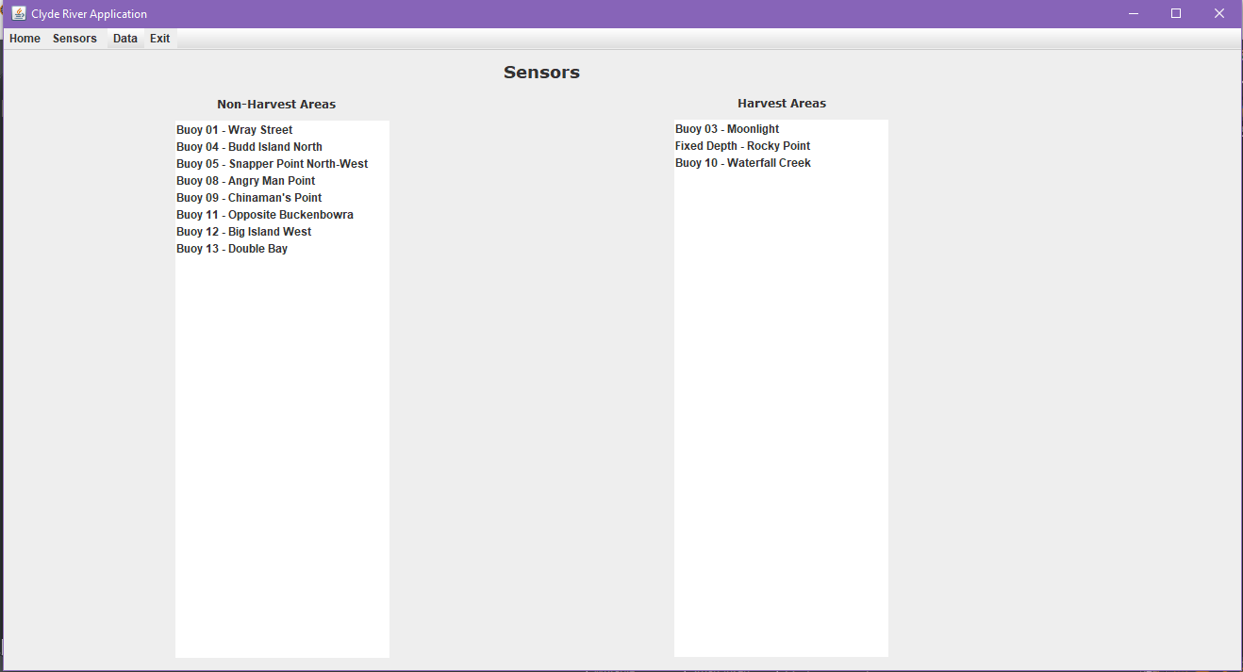

Result

